Who can benefit from promotional merchandise?
___________________________________________________________________________________________
Literally EVERYONE.

The power of promos:
- Enhance brand identity
- Delight customers and employees
- Deliver a valuable, long-lasting impression
- Create brand ambassadors amongst those who use the items
- Reward and incentivize

Our Approach:
The use of promotional items is not a one-size-fits-all approach. The brand identity, audience, objectives, budget, timing and current trends are all critical components that create a unique situation in time. We consider these components and use our industry knowledge and marketing prowess to deliver clever and creative ideas that make an impact – and are always at a competitive price.

Branded Merchandise Services  Product knowledge & experience  Industry trend knowledge  Custom recommendations and presentations  Access to thousands of manufacturers  Design and decorating  Competitive pricing  Service excellence | Online Company Stores  Site design and development  Product recommendations  Product sourcing, design and procurement  Order and inventory management  Order fulfillment  Customer communications  Internal communications | Warehouse & Fulfillment Services  Warehouse storage  Pick, pack and drop shipment services  Custom kitting  Product quality management  Short lead times  Tracking and reporting  Freight discounts
Check think3promos.com often to keep up on the latest trends and shop our store. Contact us anytime for customized recommendations.

SHOP NOW

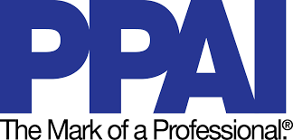
Proud members of

